‘

January 2017
Issue 2
Inside this issue:
NHS in crisis: What Lies Ahead?
Commissioner expresses grave concern over no mention of Older People in PfG.
Age Sector Platform Transport Committee meets to discuss Transports future in NI.
NPC Dignity Day a great success.
Taxes may have to rise by £1000 to cope with Ageing Population.
Interim report into State Pension Age Review.
Grandparents child care help costs them £1 billion in lost pensions.
ICTU Commends the work of Retired Members and their contribution to Society at 2 day Seminar in Belfast.

UNISON Retired Members Forum Newsletter

Hi everyone, Happy New Year and welcome to 2017. Since we last met a lot has been happening on the ground not least the break-up of the institutions, a health service in crisis, just to name a few things. In our newsletter today we take a look at the implications for the future.

NHS in Crisis: What Lies Ahead.

One of the biggest stories to hit the headlines recently is the crisis in the NHS here in the region and across the water. With the recent collapse of the institutions at Stormont the Bengoa Report has now been put on hold and this has extreme implications for people who are on waiting lists for operations and treatments. Across Great Britain including this region our Emergency Departments have been experiencing people of all ages waiting on trollies to be seen or admitted for treatment. Frustration has been shown by the public not been able to visit loved ones due to the outbreak

of the Nora Virus. More evident has been the closure of GP practices in Portadown where Doctors are at the age of retirement and are not been replaced. By March this year 16 GP’s are due to retire from various practices across the region. Here in this region alone 500 GP’s will be needed to run our practices by 2020. The former Health Minister had plans drawn up to contract out to look for young Doctors to take up post in the Portadown Practice but this fell by the wayside. According to Tom Black of the BMA the way things are going for GP practices we could very well end up paying for just visiting our doctor if things within the NHS are not sorted and put right. The NHS at all times should be free for everyone at the point of entry and no one should have to pay out for the service. Ambulance call outs were up 20% over the winter period this year. Nurses were reported in Derry to be relying on food banks to get them from one month to the next. Staffing levels also became an issue in our Emergency Depts with nurses and doctors been over worked and leading to sickness. So the question has to be asked ‘What lies ahead? For a start we as pensioners/retired members payed all our working life into our National Insurance (Continued on page 2) Contributions and our Taxes to have free healthcare and we do not want to be going down the road of paying for what is rightfully ours. Our GP Practices must be run by the NHS and the money must be put into keeping our practices open for the future.
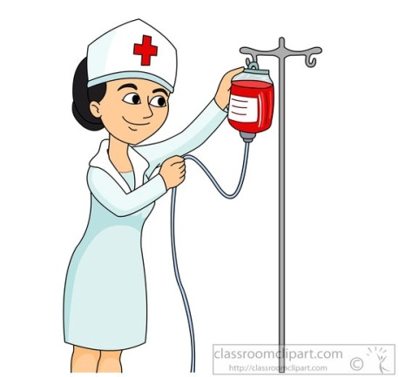
More needs to be done to keep our nurses and doctors from leaving the service after they qualify. A big pay rise should certainly be looked at especially nurses as all they have been receiving is anything from 0.5% to 2%. The pay review body for politicians last year recommended an 11% pay rise which they got so questions has to be asked as to why our nurses pay review body not recommend the same. Privatization is certainly not the way to go with our NHS and so it is important to join in on any campaign which this union sees fit to run in the near future to keep our NHS free at the point of entry for all.
Dates of the next meetings for the year At the last meeting of the Retired Members Forum a number of dates where set for our 2017 meetings as follows: 16th February, 25th May, & 2nd November. Same are subject to change depending on availability of a room.

Commissioner Expresses Grave Concern over no mentioning of Older People in Programme for Government
At a recent seminar held in Belfast the Commissioner for Older People Eddie Lynch has strongly criticised the new Programme for Government in which he says that the new document does not give any mention to Older People throughout its entirety.
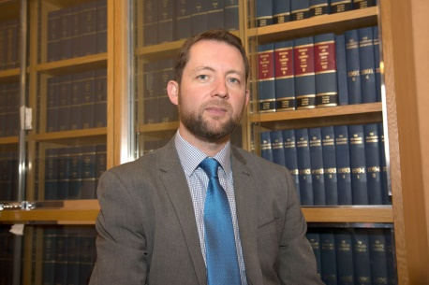
Addressing delegates at the seminar he expressed concern that Older People where been left out of the document and that more mention had been given to young people. He was responding to a PfG consultation document sent out by Stormont. He took some time to update the delegates present of his role as commissioner and said that he will do everything in his power to make sure that Older People are included. In attendance at the seminar were a number of

distinguished speakers such as Prof. Deidre Heenan (UU), Glenda Watt (Scottish Older People’s Assembly, Katrina Godfery (The Executive Office) and the Commissioner himself. A number of our own forum delegates were among the audience to hear what the Commissioner had to say. He went on to outline to the audience a number of recommendations which he drew up in a document responding to the consultation. In particular the Commissioner set out a 15th outcome which he wanted included in the PfG ‘We respect, value and protect our Older People’. Some of the issues the Commissioner want Stormont to address and make a contribution towards are matters such as: supporting and promoting better health among Older People. promoting positive attitudes towards Older People. promoting opportunities for Older People to increase their income security and supporting them from falling into poverty. More recently The Commissioner has also launched a formal investigation into Dunmurry Manor Care Home after family members and former employees raised serious concerns over the lack of care at the home. The investigation is the first of its kind in NI and is due for completion in 4 weeks’ time. We shall keep an eye on this development and keep the forum up to date with any developments on the story.

Age Sector Platforms Transport Committee meets to discuss Transports future in NI.
At a meeting of the Transport Committee of Age Sector Platform held in Belfast on the 9th February the Chair of the Committee Francis Hughes outlined to members the way forward for transport in the region. He spoke of 2 new hubs which have been given the go ahead to be built in Belfast and Londonderry at a cost of £150 million. Work is expected to commence on the hubs in 2018. A spokesman from Immac came to the meeting and spoke to the delegates about the way forward on transport. Fast lanes are being developed in Belfast and there is exciting times ahead for transport in NI. The Enterprise is currently being upgraded and refurbished at a cost of approx £4 million. Some of this money come from the European transport fund. Consultation on the way forward on transport in NI is currently out and is due to close on the 10th March. Translink is delighted by the response they have had already with well over 2000 people responding. As transport is one of the most important issues in NI we will continue to keep an eye on developments.

NPC Dignity Day a Great Success
The NPC held their annual Dignity Day Conference at the Unite Building on the Antrim Road on the 2nd February this year. The event was well attended and the audience heard a number of speakers talk about the issues facing Older People in our society.
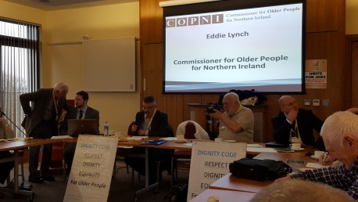
Among the speakers was the Commissioner for Older People Eddie Lynch, Eamon Donaghy (ASP), Jimmy Kelly (Unite), Brian Campfield (President ICTU) etc. Our own Mary Ferris spoke in place of Patricia Mc Keown who was unable to attend the seminar due to other commitments. The Dignity Day of Action is centred on the word Dignity which is everyone’s business.
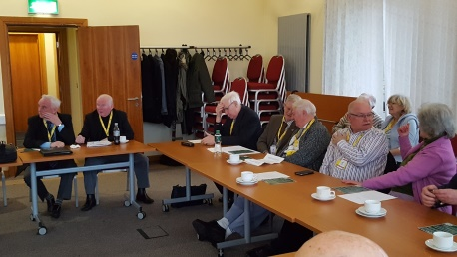 How did this day of action come about in the first instance? Over the last number of years and even up to the present day Older People have been let down in the care system and been treated badly.
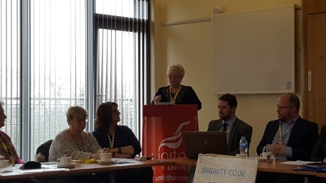
Things came to light when it was reported that Older People in our hospitals, care homes and even in their own homes where not been cared for properly and treated with dignity. So the biggest Older Peoples campaign group The National Pensioners Convention (with over 1.5 million members across the UK) felt it was time something had to be done about it and so a Dignity Code was produced. The code points to the fact that care staff should be properly trained and paid accordingly. It also states that our local health services should ensure that the code becomes part of their health and wellbeing services.
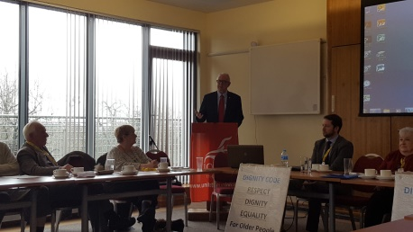
The NPC continue to campaign to have this code brought into our care homes and hospitals and it is important that we get our MLA’s and MP’s as well as our church leaders to ensure that Dignity becomes a priority. For the future we as a forum need to continue to campaign for the rights of Older People and have the Dignity Code made a priority.

Taxes May have to rise by £1000 to cope with Ageing Population. In an article which appeared in the Daily Mail back in January this year it would appear that the Government is intent to raise taxes to cope with the ageing population. The article goes on to warn us that taxes will have to rise by £30billion a decade which is equal to £1000 per tax payer in order to keep pace with the Ageing Population. In a sobering analysis it said that spending on health alone is set to double to £250 billion per year blowing an unsustainable hole in the public finances. Social care is also set to double to almost £40 billion per year which will put further pressure on budgets. A copy of the full article is available at the meeting today. But it makes you think just reading into this why we were paying our taxes to have an NHS. Already pensioners and older people as well as single parent families and those with low income already find it very hard to pay their bills or make decisions to heat or eat. More needs to be done to increase the income into the household and less into fat cats pockets.
Interim Report into State Pension Age Review The NPC have published an interim report into the review of the State Pension Age. The report ‘State Pension Age Review Interim Report’ goes on to highlight how the government is looking at increasing the State Pension Age from 65 to 67. The submission was made on behalf of the NPC Britians largest pensioner organisation with around 1.5million older people active in over 1000 affiliated groups across the UK. The NPC is run by and for pensioners and campaigns for improvements to the income health and welfare of both todays and tomorrows pensioners. The report points to the fact that in reality millions of people of working age depend largely on the unpaid work undertaken by pensioners to provide childcare and thousands of voluntary organisations depend on them to maintain the function of our civil society. The report also points out that in a modern society people in different social circumstances experience avoidable differences in health, well-being and length of life. The evidence is quite clear that any attempt to raise the SPA will therefore have a disproportionate impact on those members of society with the lowest incomes and the poorest health. It is simply unfair to build a retirement policy which fails to take account of this important issue alongside the rate of unemployment and availability of work, the rights of younger people to find a job and the loss to wider society if pensioner volunteers (currently undertaking unpaid caring and charitable work) were otherwise in paid employment.

Grandparents child care help costs them £1 billion in lost pensions.
Back in January this year the above article appeared in the Daily Mail and is been distributed at the meeting today. It refers to research which revealed that more than 100,000 grandparents are missing out on £1 billion of state pension by taking time off work to care for grandchildren. The research goes on to say that many middle age people are unaware that they can receive National Insurance Credits towards their State Pay-outs if they look after a grandchild under 12yrs while the child’s parents are at work. Government has failed to promote the scheme since its launch 5yrs ago. The scheme was designed to acknowledge the sacrifice made by grandparents who stop work to help with childcare. Off course we all know the contribution that older people make to the economy through the voluntary work they carry out, saving the government over £24 billion per year. This was highlighted in a report that Clare Keating (former COPNI) carried out just over a year ago in which she mentioned the contribution that older people make to society on a yearly bases. A copy of this article is distributed at today’s meeting for all to read.
ICTU Commends the Work of Retired Members and their Contribution to Society at 2Day Seminar in Belfast.
At an opening address to Congress, The President of the Irish Congress of Trade Unions Brian Campfield has praised the work that retired workers and older people make to society. He was speaking at the ICTU Retired Workers Seminar North/South at which delegates from different unions gathered from both sides of the border for what was to be a very informative 2 days. Before proceedings got under way everyone had the opportunity to mingle over a buffet lunch provided for delegates on arrival. Day 1: As delegates began to settle into their places and listen to the opening speech by the president of the ICTU the room fell into silence as Brian Campfield continued to deliver a warm and welcoming speech. In it he particularly welcomed the delegates from the different unions who
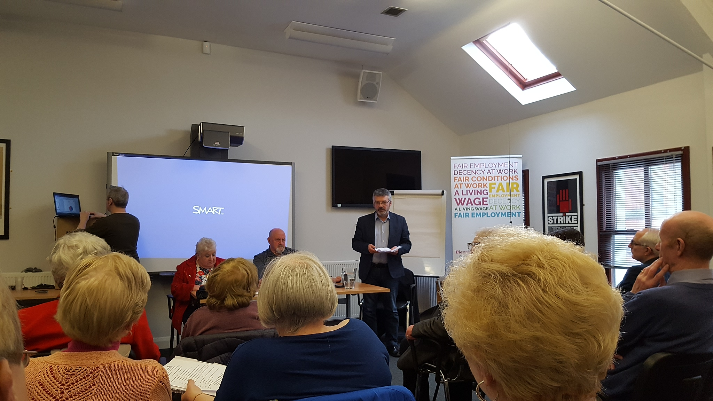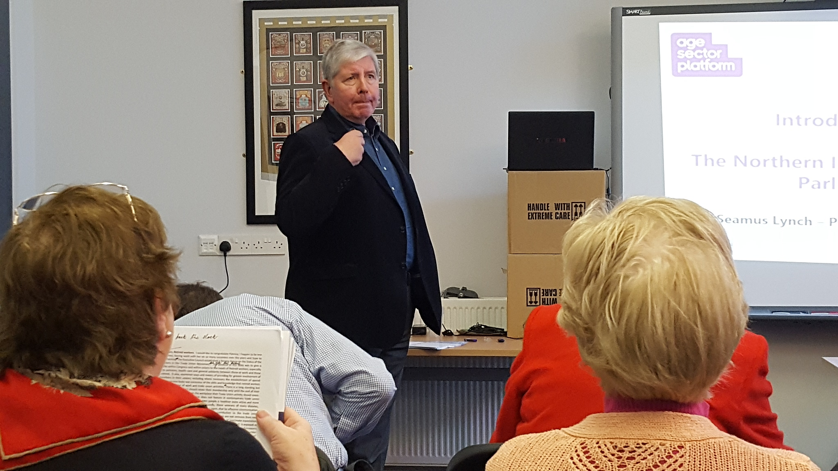
travelled all the way up from the south for the 2 day event. A number of distinguished speakers had been invited along to the event to give a talk to the audience. They included such names as Eddie Lynch(COPNI), Seamus Lynch(ASP), Neil Duncan- Jordan(NPC) and Rauiri Fitzgerald(ETUC). Chairing the 2 day sessions was Michael Duffy and Margaret Galloway. Rauiri Fitzgerald who had travelled all the way from Brussels to be there began by talking about the Impact of European Union issues on Retired Workers. He went on to highlight that the link between generations was very important and that people need to work together if we are to make a difference for the future. He went on to say ‘Why activate intergenerational approval?’ Some of the reasons he give was as follows:
- High unemployment rates.
- Positive negotiations by Trade Unions.
- Healthy safe working programme.

Retired Members Bus Run
Discussion regarding our bus run for this summer is due to take place today. It’s important as a forum that we take time to socialise together giving us a break from the excellent work we do. All your ideas are welcome.
Thank you.

(Contd from p5)
- Had to have a clear demographic scope of intergenerational outcome.
- Agreement had to be signed between Employers and Unions
- Strategic.
- Health & Safety at the workplace.
- Intergenerational approach.
- Skills and competent management.
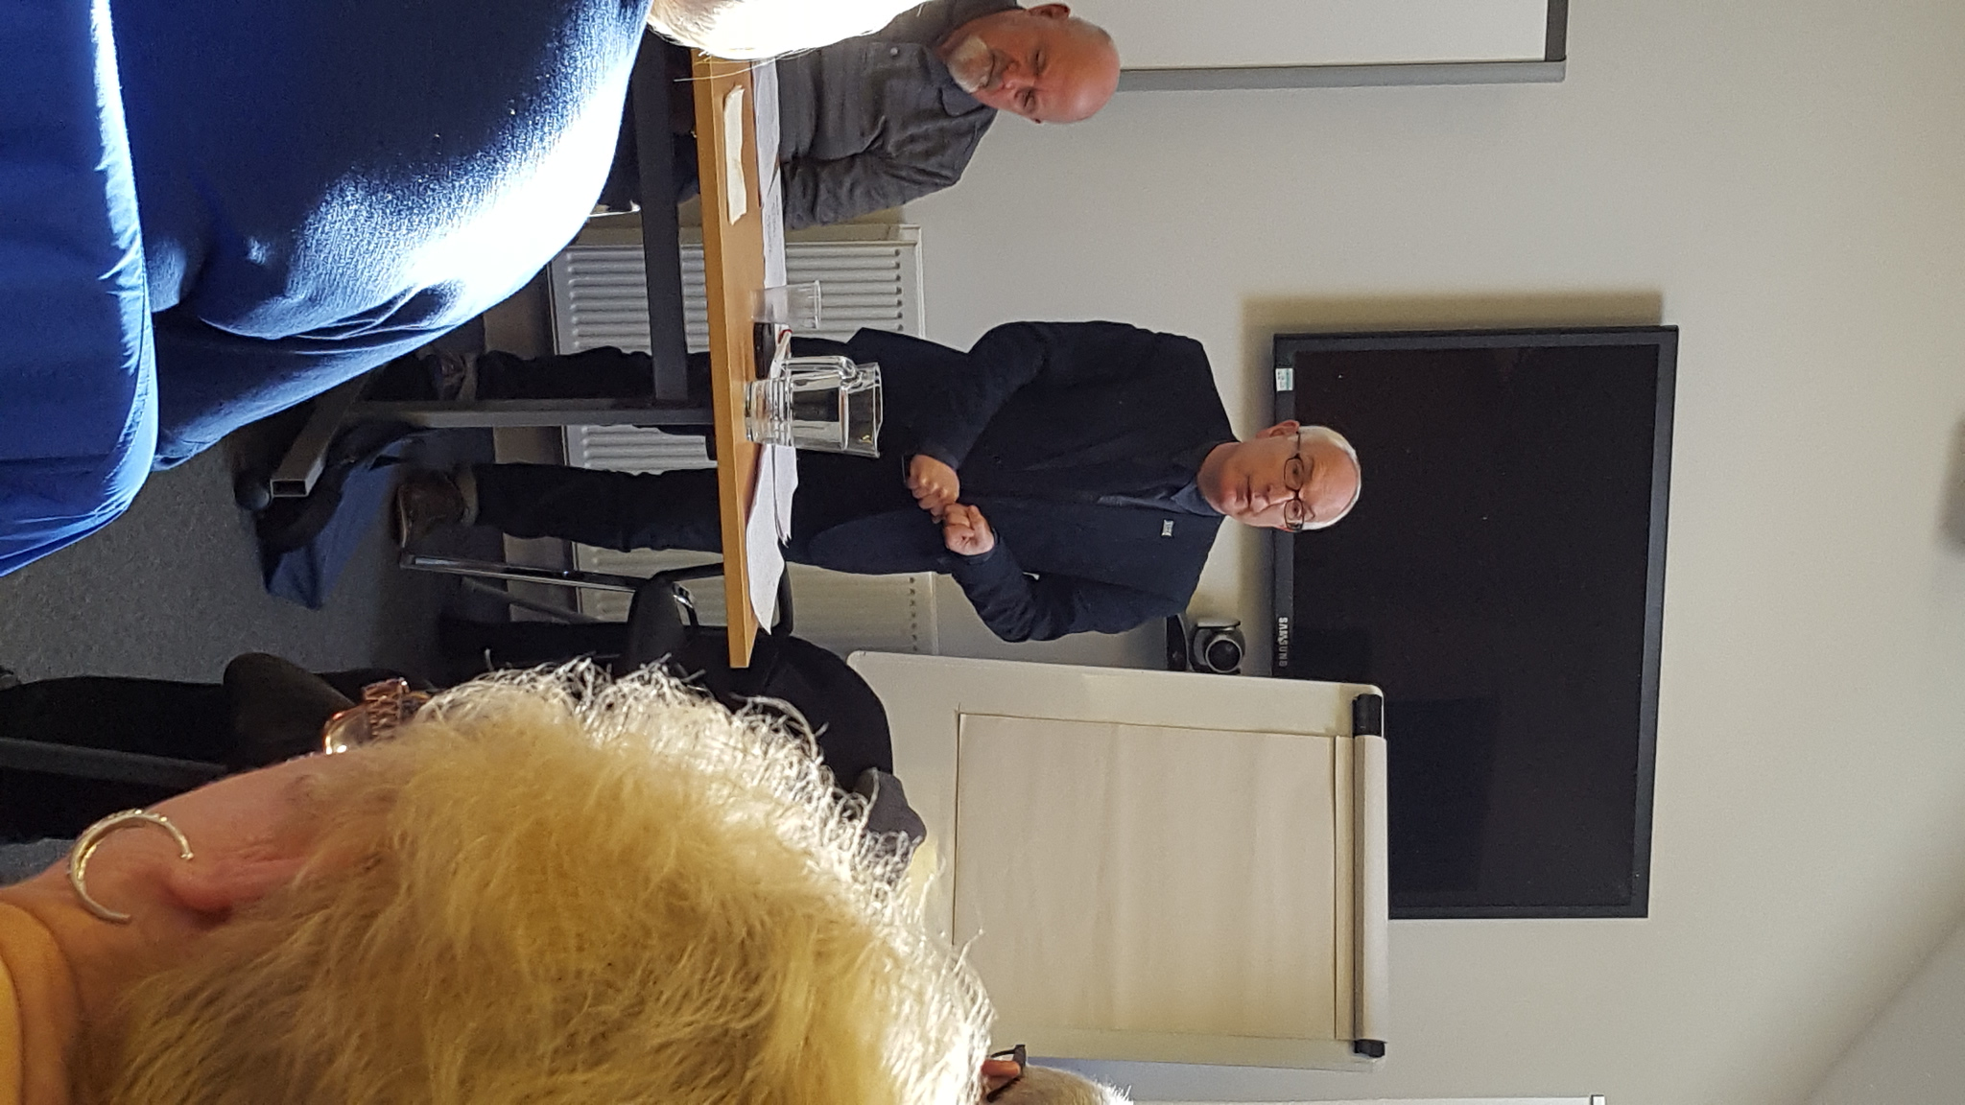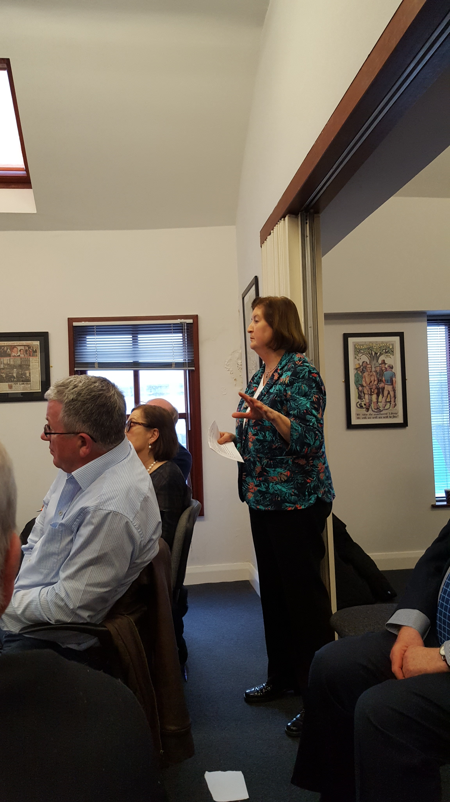
Neil Duncan- Jordan then went on to speak about the Impact of Brexit on Retired Workers. As he joked about he began talking about the hard Brexit which may lie ahead. He said that we could see taxes rise substantly in the future to help pay for our services and restrictions placed on our labour force. He went on to speak about the review of the pension age and how it is going to affect everyone if implemented. He went on to say that anyone under 40yrs now will have to wait until 70yrs before receiving their pension. Neil pointed to the fact that 80,000 care workers could be lost as a result of the Brexit. He said that social care will increase over the next 20yrs. Seamus Lynch then spoke about Age Sector Platform and the Northern Ireland Pensioners Parliament (NIPP) and highlighted how everything developed to where we are at present. He spoke of the great work that has been done by the NIPP and the representation we make on behalf of older people to Stormont. He also spoke about the research which has been carried out at our local parliaments and the campaigns both locally and taken to Westminster that has been successful. Finally the last of the speakers Eddie Lynch began speaking to the delegates present. As he was introduced he received a warm round of applause. Eddie began by outlining to the audience his role as the Commissioner for Older People in Northern Ireland (COPNI). He spoke about the excellent work that older people do within the community and the importance of the voluntary contribution which saves the government over £24 billion per year. In his deliverance Eddie spoke about the scams which older people face and highlighted the increase in crime in relation to this. He also spoke about the PfG in which older people were not mentioned once throughout the document. Goods Facilities and services for older people is just one of the important issues that needs to be addressed within the Programme for Government and the Commissioner said it is important that Stormont implements the 15th Outcome into the PfG that Respects, Values and Protects older people.

(Contd from p6)
After Eddie finished with his deliberation to the audience he received a very warm applause and standing ovation. Delegates from the South where in awe of the Commissioner for Older People as they do not have one themselves. A handout from the commissioner’s office was available for everyone to avail off called ‘Who’s Calling’ and there is one each for the Forum members. After a break from proceedings the next speaker took up her place on the floor. Dr. Lisa Wilson a Senior Researcher with NERI began to speak on ‘The Economic Contribution of the Aged’. She spoke about the great contribution that older people makes each year to the economy thus saving the government up to £24 billion. Grandparents volunteering to look after their grandchildren or volunteering to do work has a significant impact when it comes to saving finances. She pointed to the fact that the previous Commissioner for Older People Clare Keating highlighted this in a report carried out by her office at the time. She also pointed to the fact that older people especially those attached to Unions and who are retired from their jobs contribute a great deal of time to campaigning for the rights of older people on such issues as Pensions, Health and Transport. Day 2: On day 2 of the event delegates began to arrive at the venue and settle in to the room. The second day was going to be centred round listening to the different heads of the unions here speak a bit about what their retired members do within the organisations. Among the speakers was Patricia Mc Keown (UNISON), Paddy Moran (SIPTU), Jimmy Kelly (UNITE) and Owen Reidy (ICTU Ass. G.Sec). The theme was set around 2 questions ‘What should unions do for their retired members’ plus ‘What can retired members do for their unions’ and each speaker took the opportunity to address the audience by outlining the excellent work and time their retired members put into campaigning for the rights of others and getting involved in such organisations as ASP, NPC, etc. After all the speakers finished speaking the chairs asked for all the people to organise into 3 groups for to commence the workshop. The theme for the workshop was on retired workers getting the best from their union. The groups where then called back to make a report back on their findings and a letter was drawn up with recommendations to be forwarded to the ICTU executive council. Finally the 2nd day ended with a buffet lunch for all and the delegates made their way home.

Education, Education, Education.
Unison is holding a course for members of the union who are considering retiring from their jobs in the near future. The course ‘Planning for Retirement’ will take place in the UNISON Centre in Derry on the 7th April beginning at 10.30am and finishing at 3.30pm.
ALSO
Free Maths and Computer Courses for all UNISON members.

Ever thought on becoming a UNISON Retired Member and making a difference.
Well you can.
Join
UNISON’s Retired Members Forum
Be part of our work programme and get involved in our various groups and campaigns
NOW.
Working for a better future.

