Celebration of Margaret McKee and Elizabeth Cameron

The Women’s committee organised a evening Thursday 27th April @ 6 pm in Galway House to celebrate Margaret McKee’s achievement in recognition of the Gold Badge award, this was in the form of a film night, (Suffragettes). Patricia and Pamela both spoke about Margaret and her work in the union. Flowers where presented by the chair of the women’s committee Roberta Magee. Also invited was Elizabeth Cameron who was nominated for the Hero award which was organised Nationally.

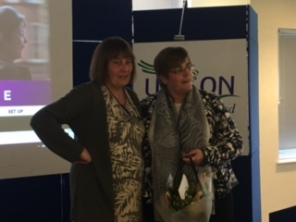
Margaret McKee and the Royal Branch

Elizabeth Cameron& Roberta Magee

